**Lab6 Software Writing for Timer**

**and Debugging**

Name:Zihong Yi ID：U201613634

What we have done?

We set load register with different numbers for different time delay by reading the values of switches. And once the timer come to zero, the counter will add one to the number which is displayed on the LEDS. However, the whole progress will exit and holds on displaying the same number once the buttons are pused.

How we calculated the timer setting?

The setting of timer is the result of half of CPU clock divided by 10 multiplying with a constant. Once the timer goes to zeros, the timer will interrupt and the counter will add one to the number displayed on the LEDS. If the load register is 32500000, the timer takes 0.1s once with the reason that the timer counts one after two CPU clocks and 32500000 is 1/20 of CPU clock. Therefore, the elapsed time is dip_check*0.1s.

Load register values

#define ONE_TENTH 32500000 // half of the CPU clock speed/10

SWITCHES:0010

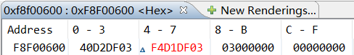

There result is 0x03DFD240, which is 62000000=2*ONE_TENTH

SWITCHES:0101

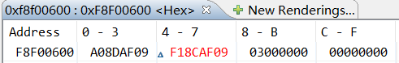

The result is 0x09AF8DA0, which is 1625000000=5*ONE_TENTH

SWITCH:1110

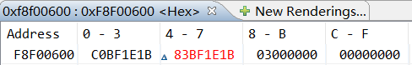

The result is 0x1B1EBFC0 : 455000000‬=14*ONE_TENTH